
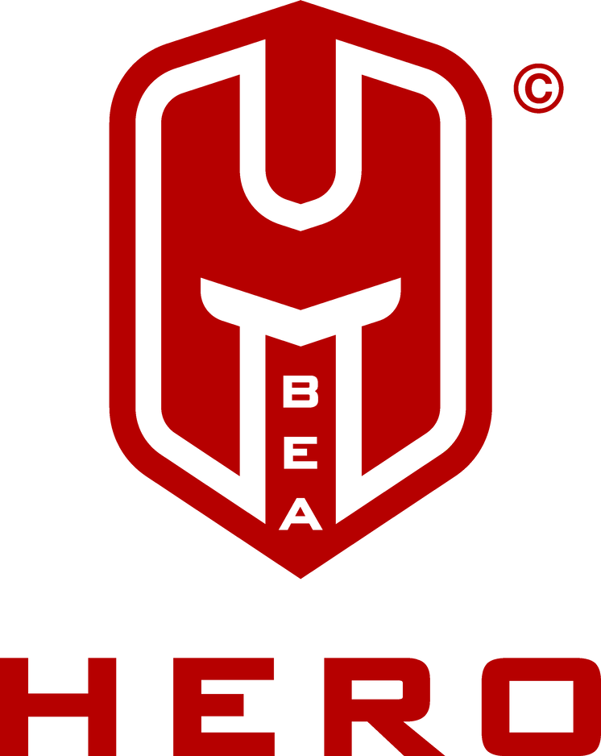
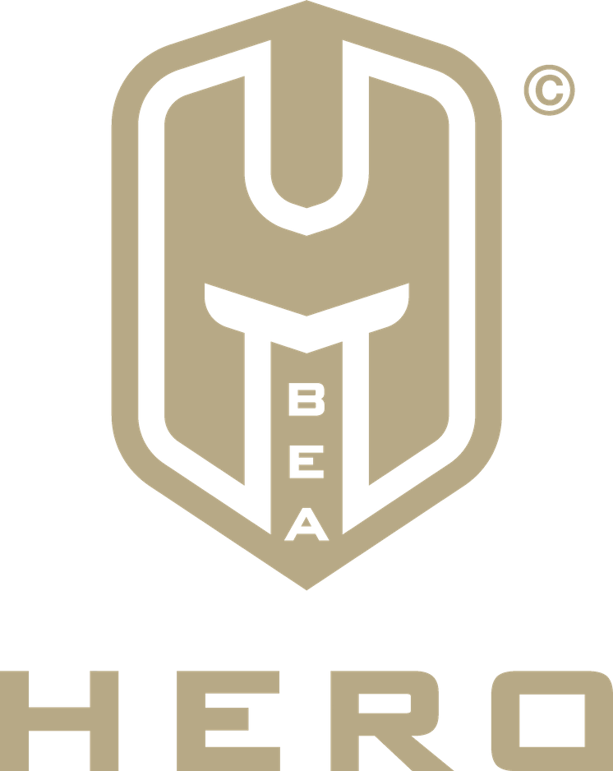
BEA HERO
THIS IS TO CERTIFY THAT
Name Surname
HAVING SUCCESSFULLY COMPLETED THE SACRAMENTUM
OF HEROES WAS ENLISTED AS
Hero-in-the-making
DATE 01 January 2020
Alessio FavareTto
DanielChadeyraS
Alessio Favaretto
Chancellor and Founder
Daniel Chadeyras
Vice-Chancellor and Co-Founder

